TELEGRAM BOT PROJECT WITH PYTHON

USER MANUAL



This document has been prepared to explain the Telegram Bot Project which is coded in Python programming language. (For now, the Bot works in Turkish.)

- The Telegram website is searched from Google and the site marked with red is entered. (You can also use the mobile application. In this document the InnoBot used via Telegram Website.)

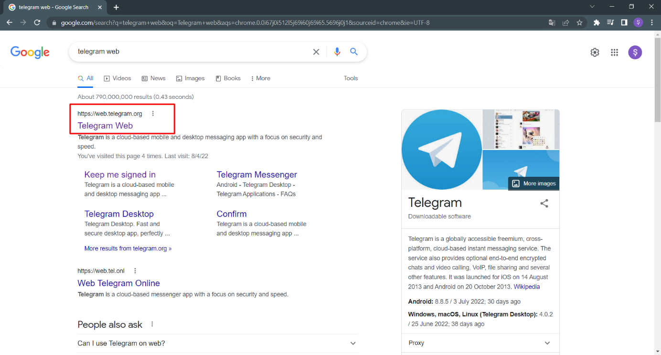

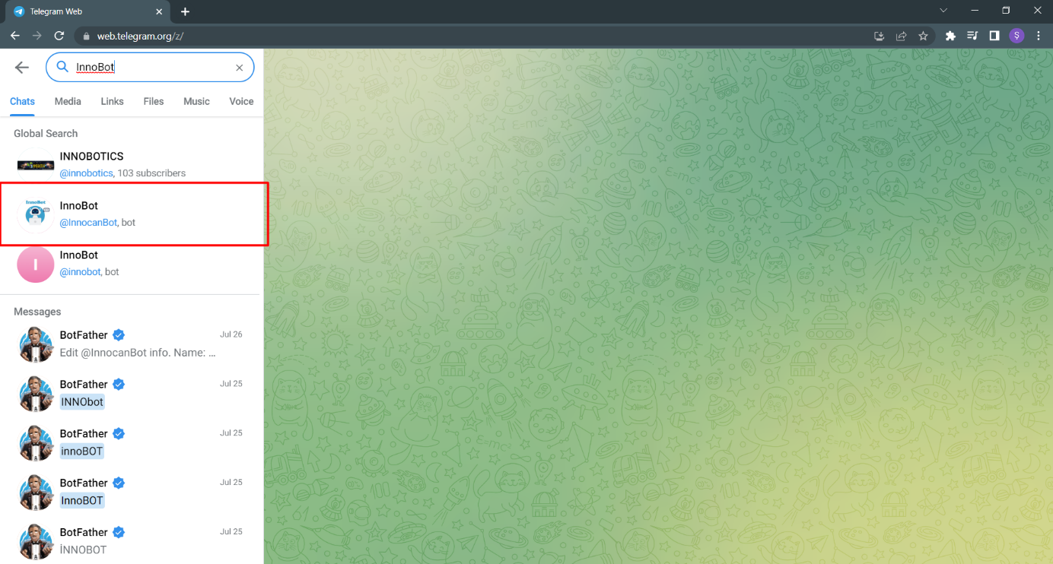 -Then, after registering with personal account, the bot is accessed by typing ***InnoBot*** or ***@InnocanBot*** in the search box.

- InnoBot is started by pressing the start button on the landing page.

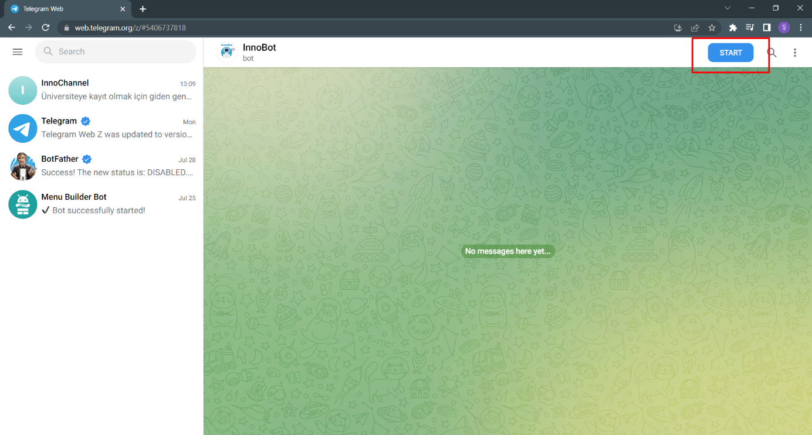

* Innobot starts to work after pressing the button and sends a message about commands that can be used. The following commands can be typed according to the desired operations.

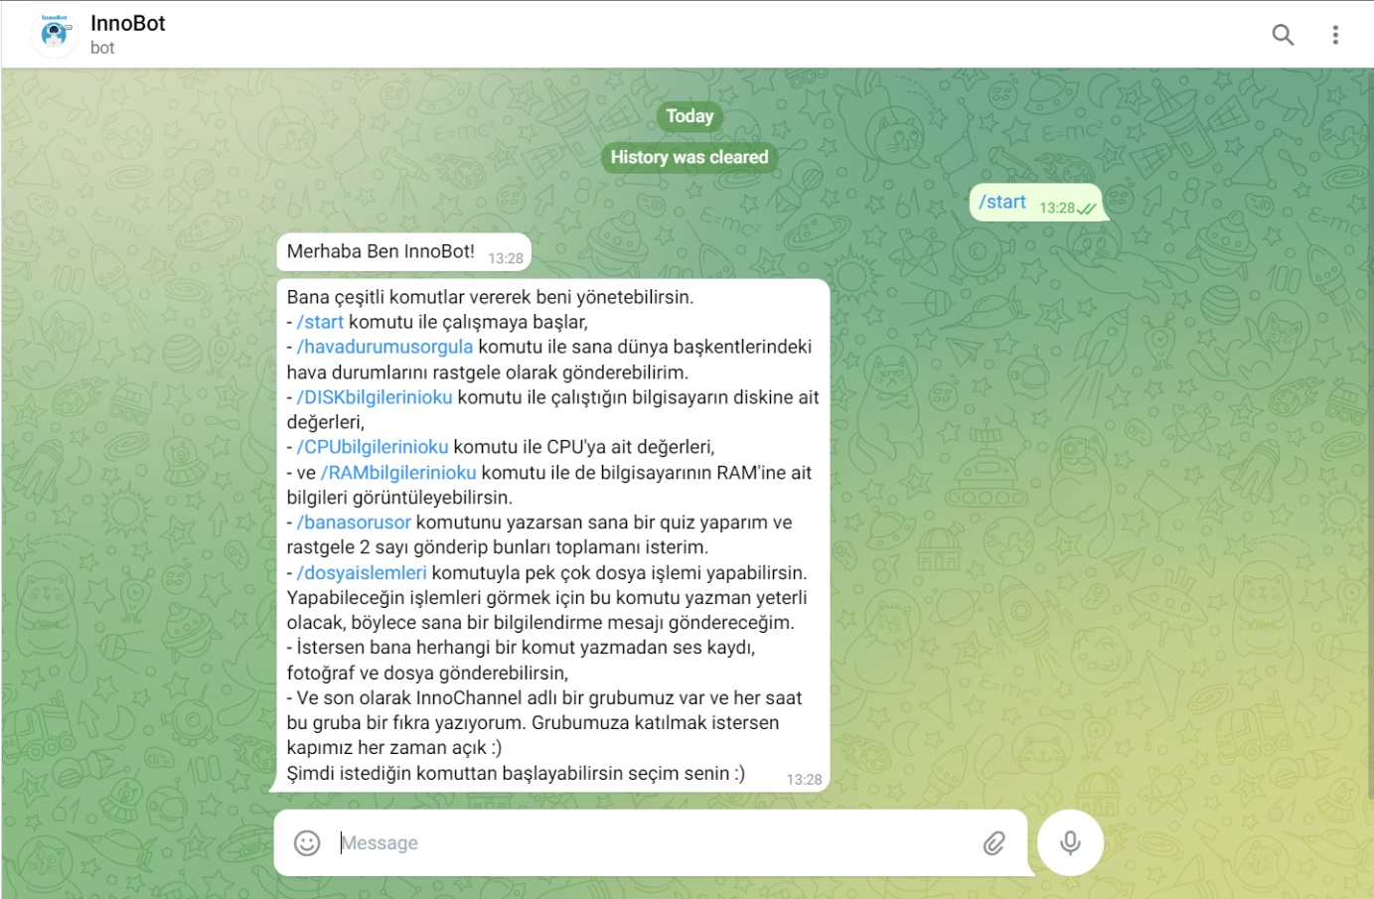

- By typing the ***/havadurumusorgula*** (interrogate about the weather) command, the weather conditions of the capitals of various countries can be obtained from the bot. Weather information will come randomly every time the command runs.

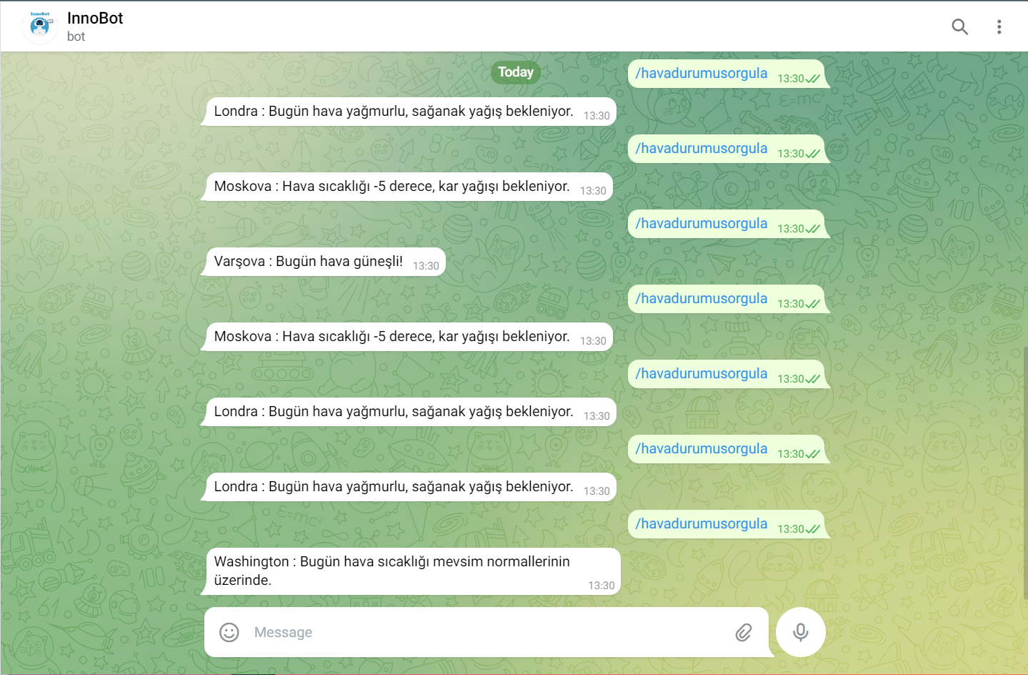

* With the ***/CPUbilgilerinioku*** (read the CPU informations), ***/DISKbilgilerinioku*** (read the disk informations) and ***/RAMbilgilerinioku*** (read the RAM informations) commands the CPU, disk ve RAM information of the working environment is read and sent to the user.

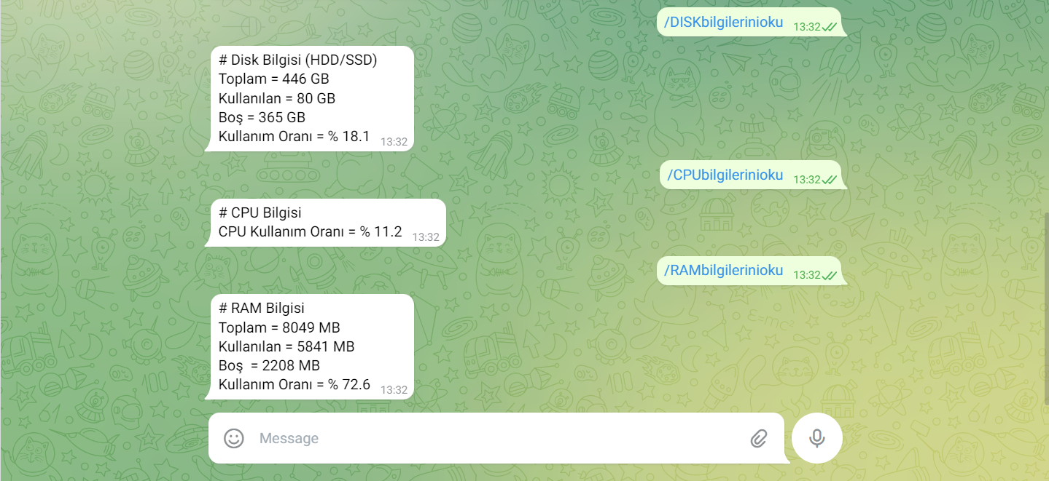

***-*** When the ***/banasorusor*** (ask me a question) command is executed, InnoBot randomly selects 2 numbers and asks the user to add these numbers. For a correct answer, a confetti will explode on the screen, and for an incorrect answer, a red cross will appear on the screen, indicating that the answer is incorrect.

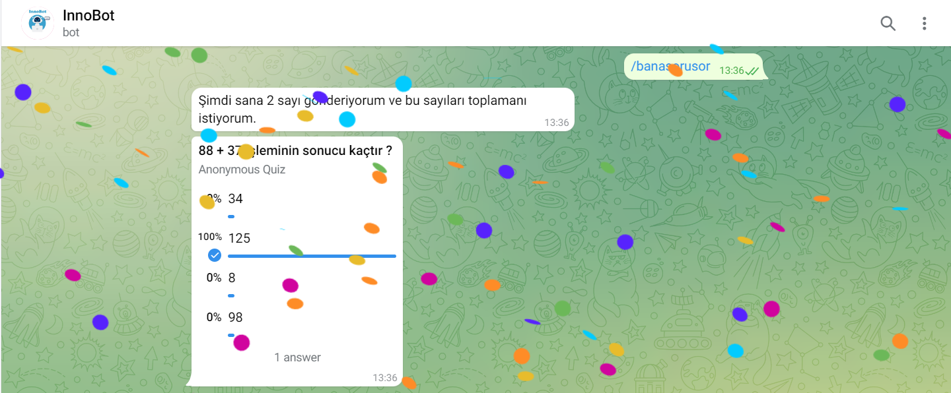

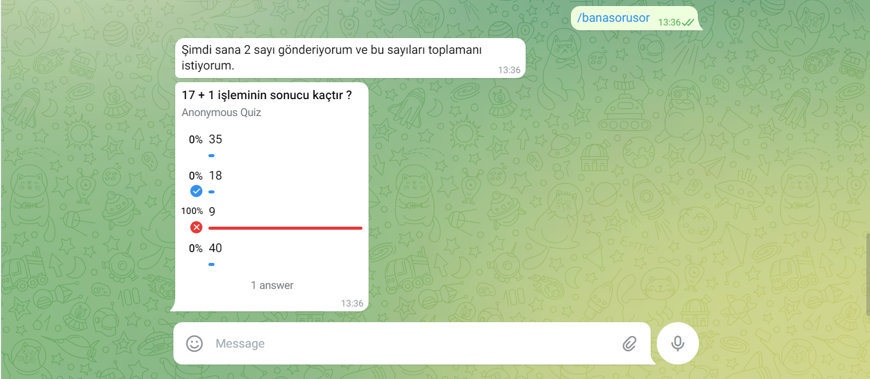

- When an undefined command is entered or a message is written to InnoBot, the following warning will be display.



There are many file operations the bot can do. In order to get information about these operations, ***/dosyaislemleri*** (file operations) command should be written to InnoBot. After typing this command, the bot sends a message and lists the commands that can be used to perform file operations.

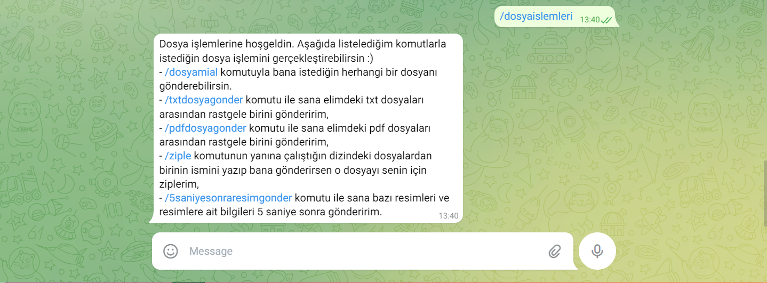

-When a file name is typed next to the ***/dosyamial*** (take my file) command, InnoBot sends the file back to the user. The point to note is that the /dosyamial command does not work alone. Therefore, a valid file name must be entered. (Currently, operations can be performed with files in the directory where the script file is located.)

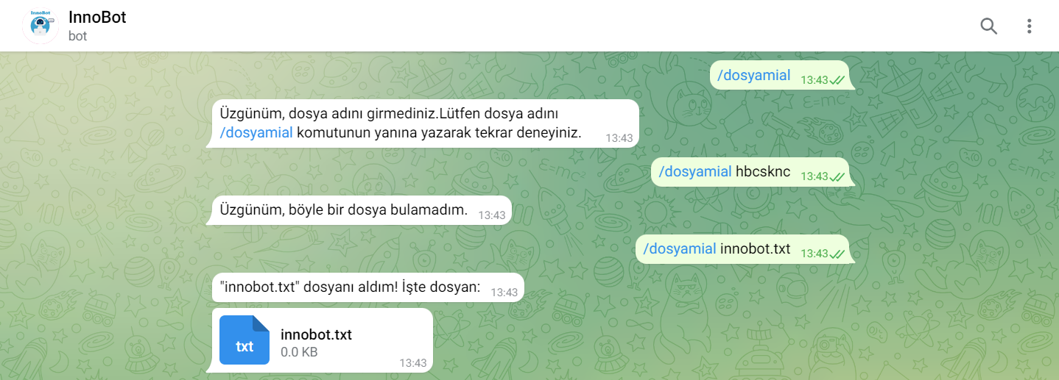

***-***With the ***/txtdosyagonder*** (send me a txt file) command, the user can randomly retrieve .txt files from the bot. Each time the command runs, another file will come. In the txt files, the names of the movies with the highest IMDB scores, IMDB scores and topics are written.

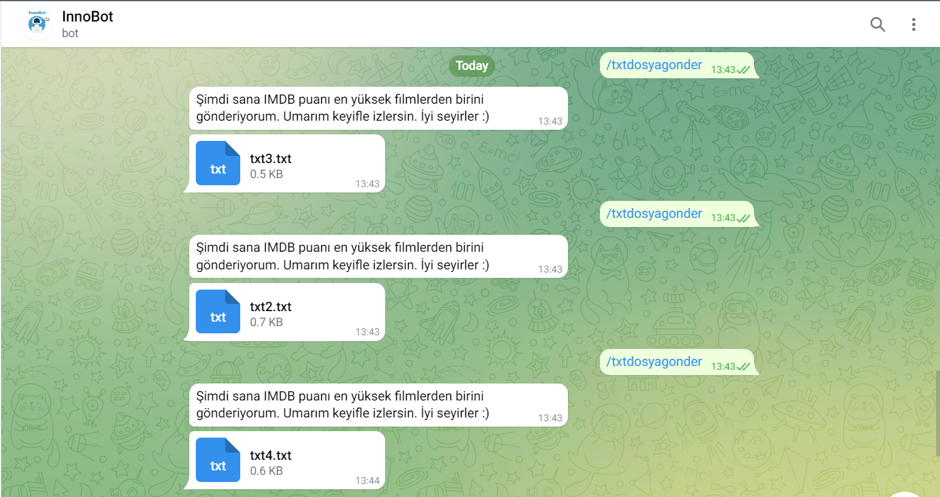

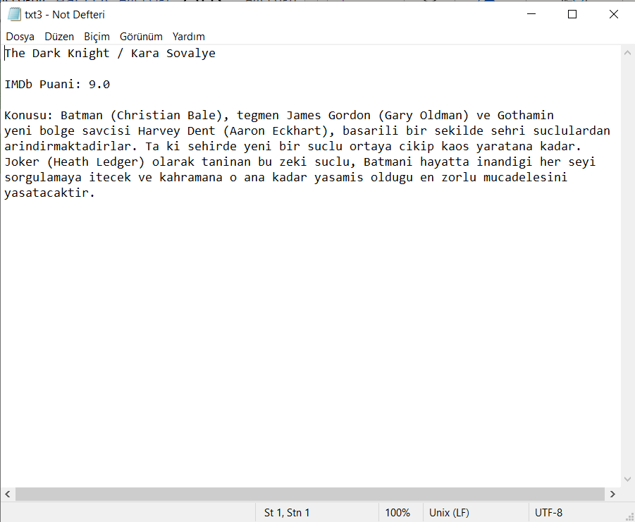

***-***With the ***/pdfdosyagonder*** (send me a pdf file) command, the user can randomly retrieve .pdf files from the bot. Each time the command runs, another file will come. In fact, unreal human images created with artificial intelligence are placed inside the pdf files.

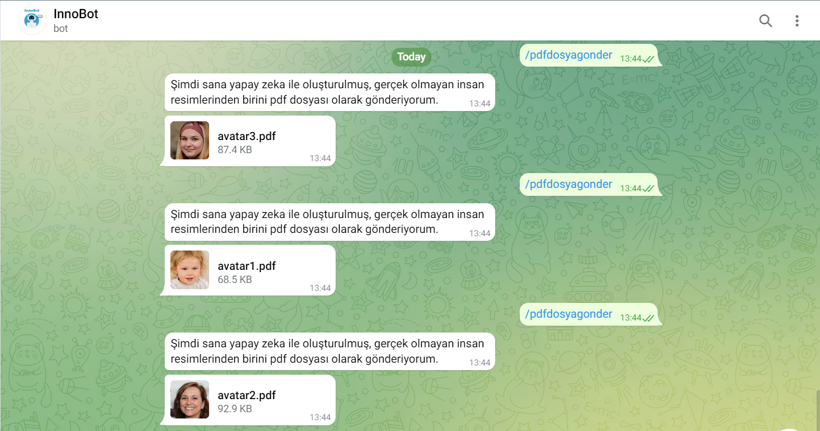

***-*** When a file name is typed next to the ***/ziple*** (compress) command, the named file is compressed (zipped) by InnoBot and sent to the user. As with the /dosyamial command, the /ziple command does not work alone, the name of a file in the directory where the script file is located must be written next to the command. When a non-existent file name is entered, the bot sends a warning message. Another important point is that the bot does not zip files larger than 1 MB in size.

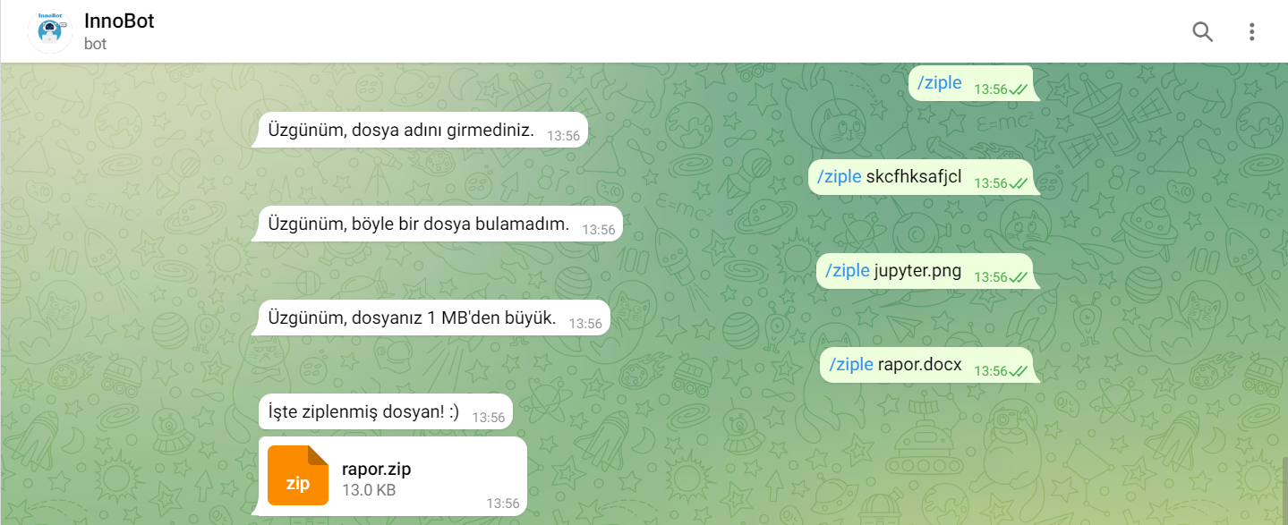

***-*** 5 seconds after the ***/5saniyesonraresimgonder*** (send me a picture after 5 seconds) command is executed, InnoBot sends a picture of one of the planets in the Solar System and some information about that planet. Each time the command is run, a different information and picture is expected.

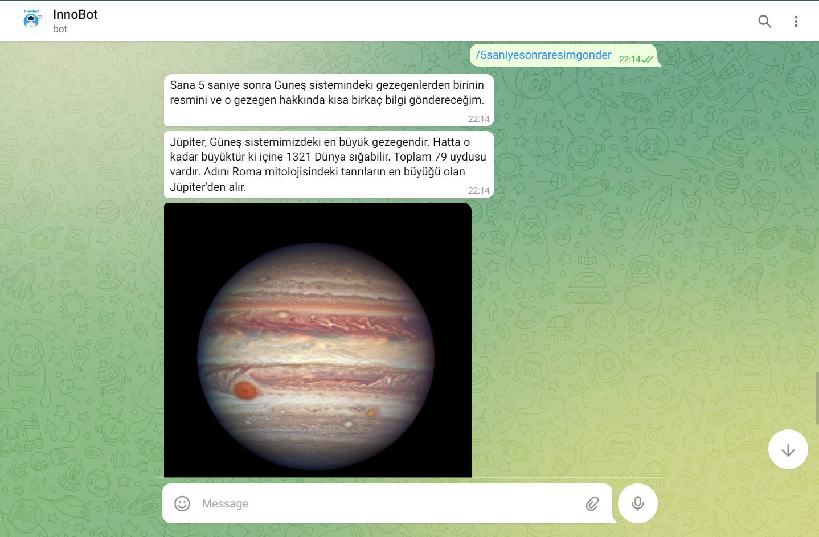

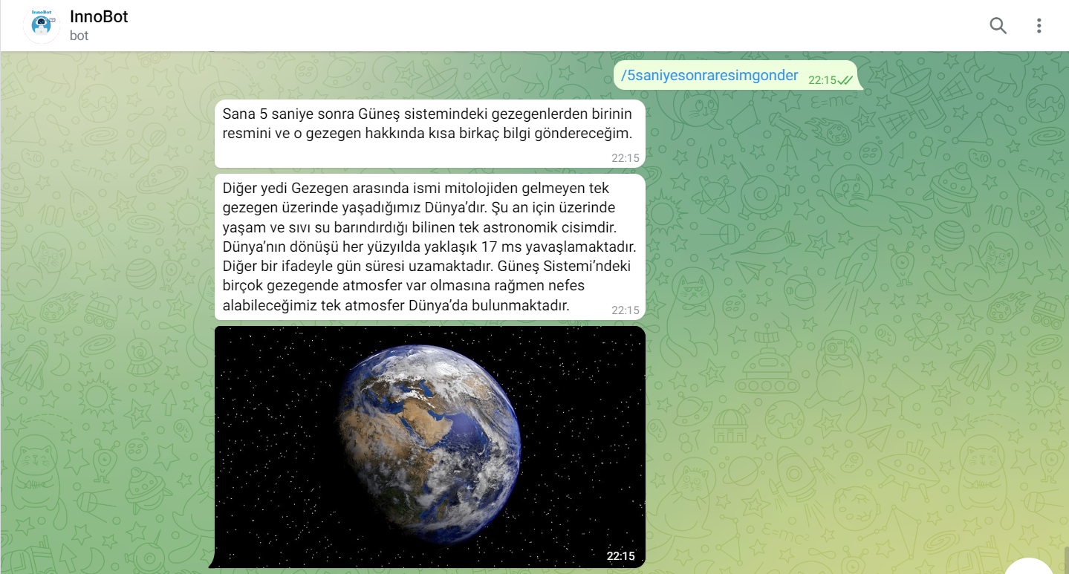

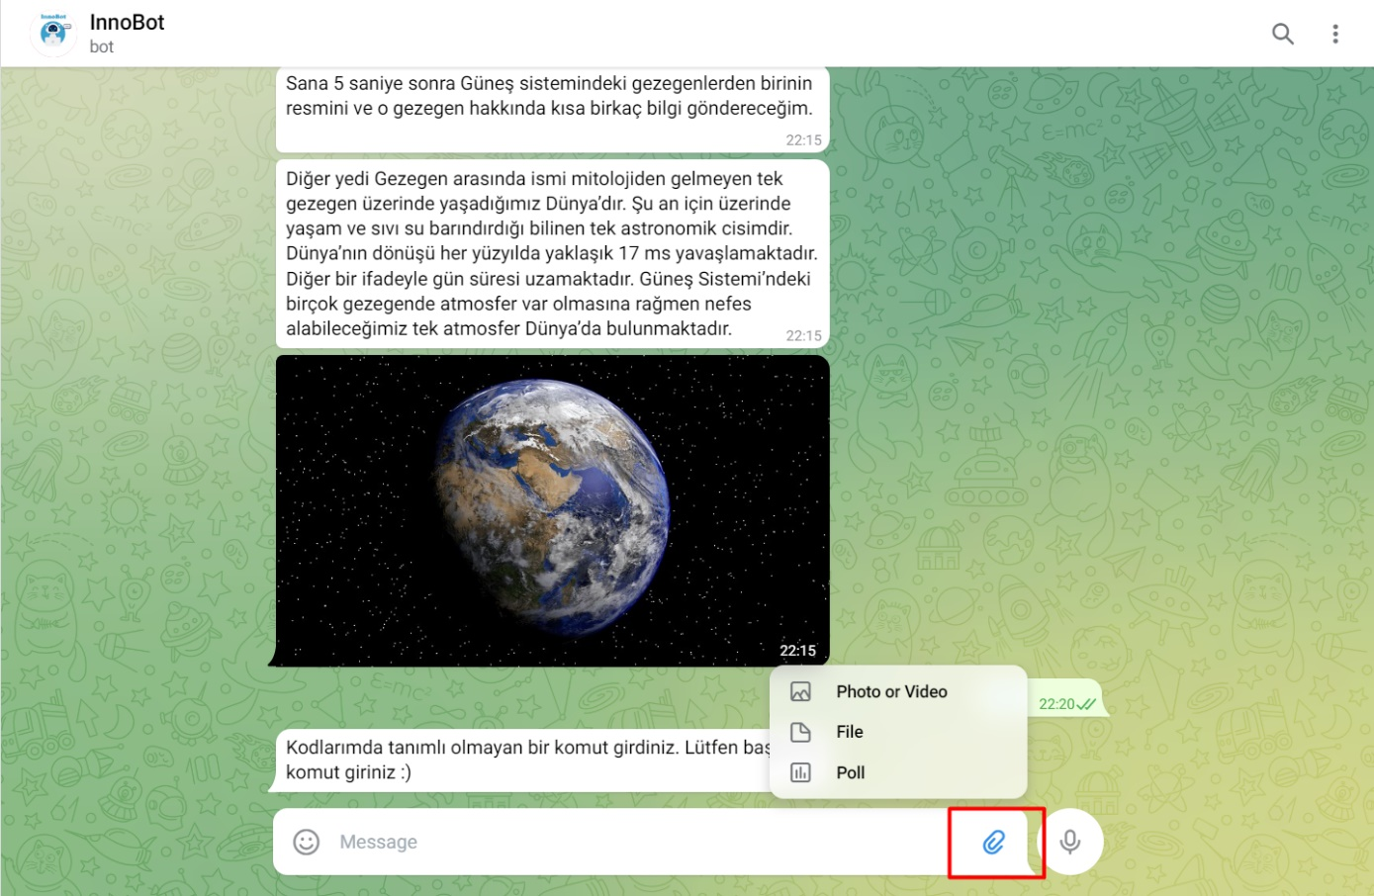 - By clicking on the icon marked in red, photos, documents and audio recordings can be sent to InnoBot without any command.

- If desired, photos can be sent instantly from the memory of any device. In response, InnoBot sends the same photo back to the user.

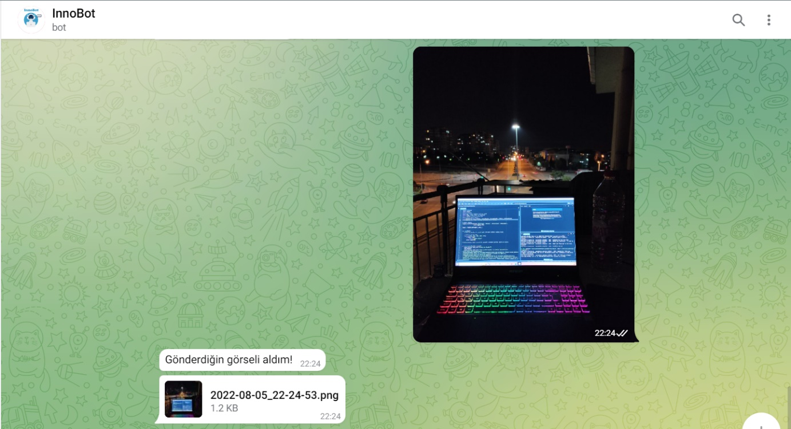

- If the audio recording and the file are sent to the bot, InnoBot sends the same audio recording or file back to the user.

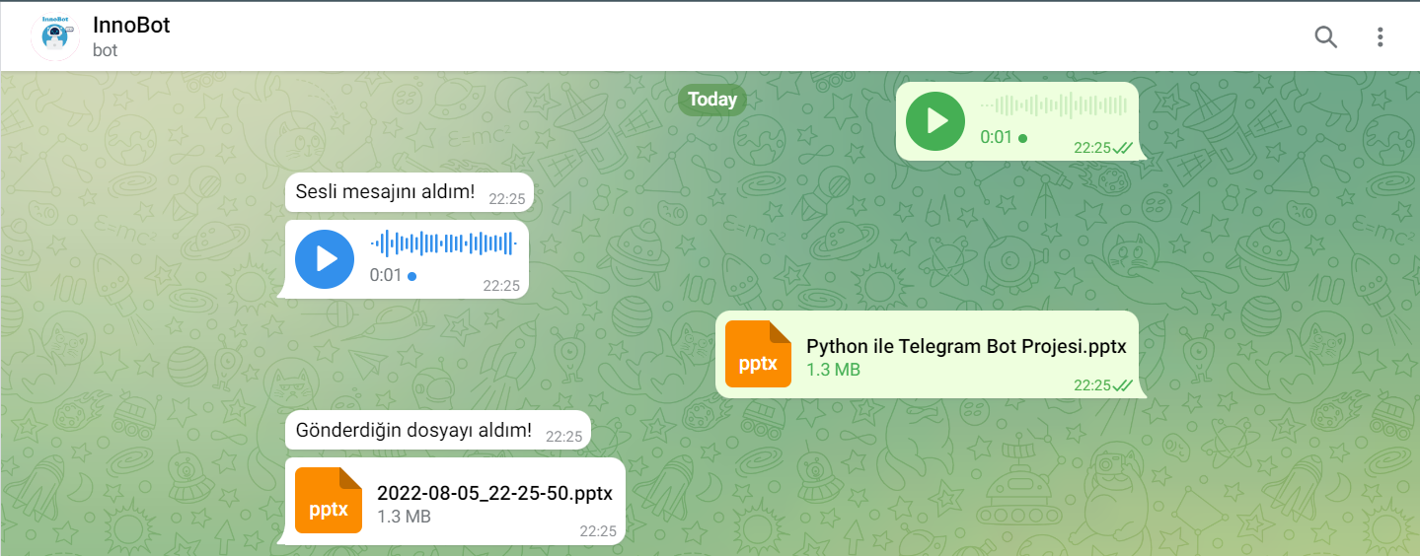

**-** InnoBot is a member of a group called InnoChannel and sends a joke to this group every 1 hour. Group information is indicated in the screenshots below. (Group link: https://t.me/+TLXvPchoGaw1NTQ0)

